**Challenge 4: Enable Triaging and Clinical Support Systems**

**Objective:** To provide an efficient and seamless telehealth session with appropriate providers or hubs by intelligent routing through triage and clinical support

**Benefits:**

* Provides appropriate and on-time care cost-effectively
* Reduces overcrowding or unnecessary queues for telemedicine
* Reduces wait time and bottlenecks by processing patients more efficiently
* Provides rapid care to patients with low-risk health conditions.

**Features:**

* ***Implemented Features***
* Triage based on symptoms. This feature enables routing of a patient to the appropriate department
* Probable diagnosis based on the symptoms
* Algorithm gives a recommendation of investigations and treatment based on probable diagnosis.
* Added auto-suggestion of symptoms when user enters the name of symptom.
* Patient can see only probable diagnosis and department while the doctor/nurse view will be able to see diagnosis, department, investigations, and treatment.

* ***Suggested Features (Future scope of enhancement)***

Tele-triage additional features that can be implemented.

* Based on person requirement [telemedicine now and scheduled appointment]
* Based on age [pediatric, adult, geriatric]
* Based on language catering to local language [provider speaking local language and telemedicine UI in local language]
* Clinical decision support based on medications prescribed such as drug-drug interaction, duplicate drugs etc.
* Clinical decision support based on patient’s location such as air quality etc.

**Assumptions:**

* Due to limited data points, we have assumed that each symptom will equally qualify for a diagnosis but that is not the case. When we have more datapoints available (weighted average of each symptom towards a probable diagnosis), the algorithm can be further enhanced to improve the accuracy of the results provided by the algorithm. Also, we can change the method from cosine similarity to tf-idf weighted average with cosine similarities.

**Technical Design**

1. **Architecture Diagrams**

**This module will come under UHI and the EUA/HSPA will call this module as an API, and they will be able to get the desired result.**

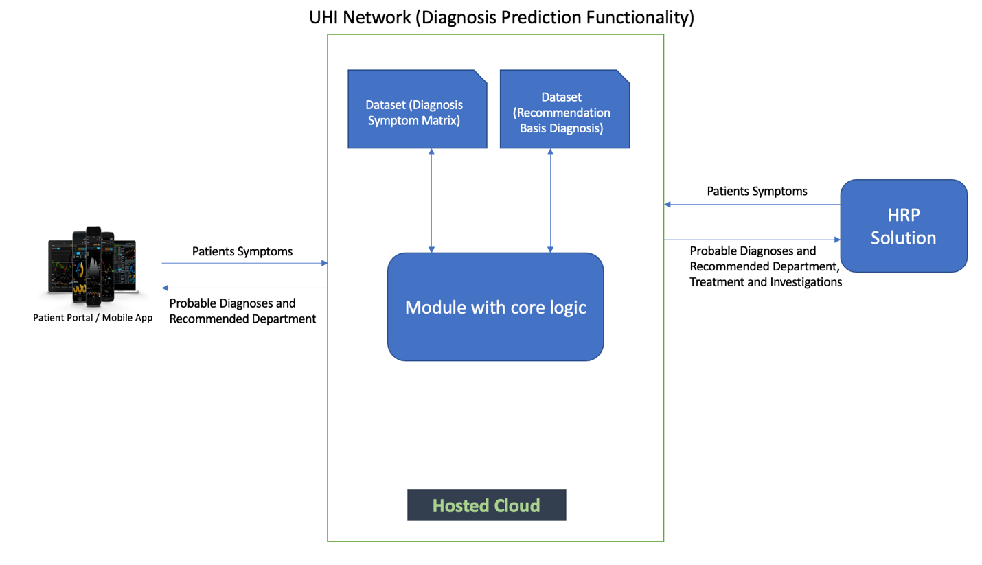

The components of current module are –

* **Frontend (UI) –** 
  + Symptoms are entered either by the patient/doctor/nurse. **Auto suggestion** **of symptoms** is also implemented to give ease of use during entry of symptoms.
  + There are 2 main workflows –
    - **Patient View –** Patient will enter the symptoms and will be able to see the **probable diagnoses and the recommended department** for those diagnoses.
    - **Hospital Staff View –** Hospital staff will be able to enter the symptoms for the patient and they will be able to see the **probable diagnoses as well as the recommended treatment, investigation(test) and the department** that the patient can be referred to.
* **Backend (API) –**
  + There are two main APIs –
    - **Diagnosis Prediction API –** This API predicts the probable diagnosis based on the symptoms entered by the patient. This API uses a methodology called Cosine Similarity to calculate the probable diagnosis, can be further enhanced with tf-idf weighted average if data points are available.
    - **Recommendation API –** This API recommends possible treatment, investigations, and department a patient could be referred to.
* **Datasets –** 
  + There are two datasets available –
    - Symptom Diagnosis 2 D Matrix
    - Department, Investigation and Treatment Recommendations

**Both these datasets have been uploaded on GitHub Repository.**

1. **Model APIs and Sample Data**

We have deployed our API’s on Heroku platform. The URLs to our API’s are –

* **Auto suggestion API: -**

URL – <https://intelli-search-csh.herokuapp.com/autopredict>

This API gives patient/hospital staff auto suggestion when they are entering the symptoms and helps them quickly select their symptoms and hence promotes ease of use.

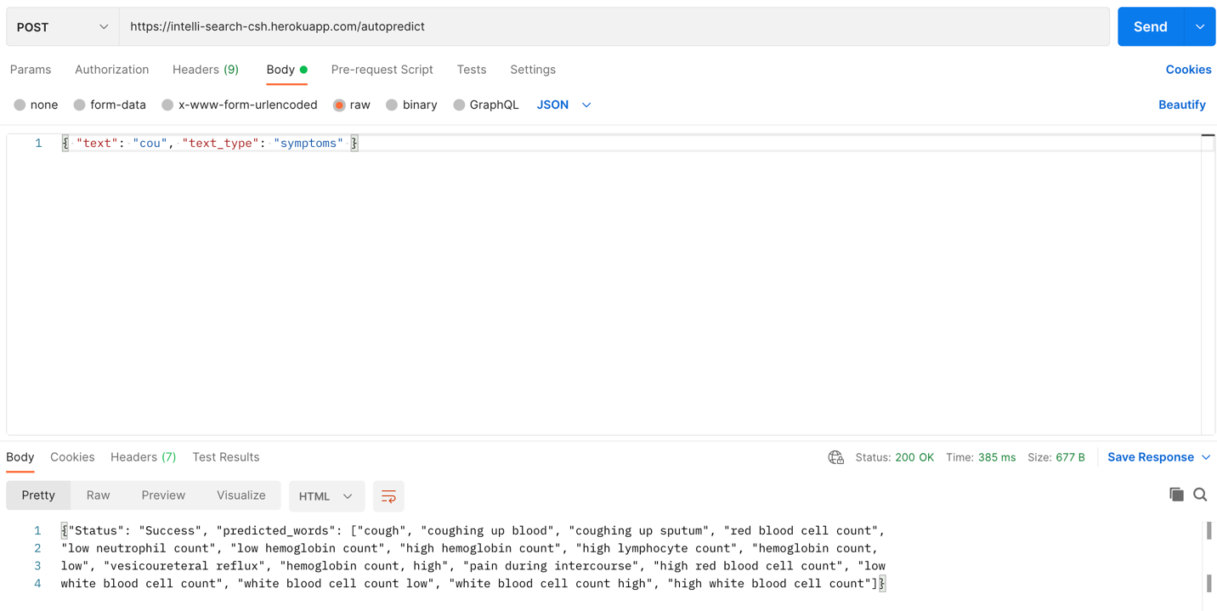

* **Diagnosis Prediction API: -**

URL - <https://diagnosis-prediction-model.herokuapp.com/diagnoisPrediction>

This API gives patient/hospital staff the probable diagnosis based on the symptoms entered with the probability of that diagnosis. This helps the hospital staff/ patient to see all the probable diagnosis and find recommendations for each diagnosis.

This API used the methodology of cosine similarity to calculate the probability for each diagnosis against the symptoms entered.

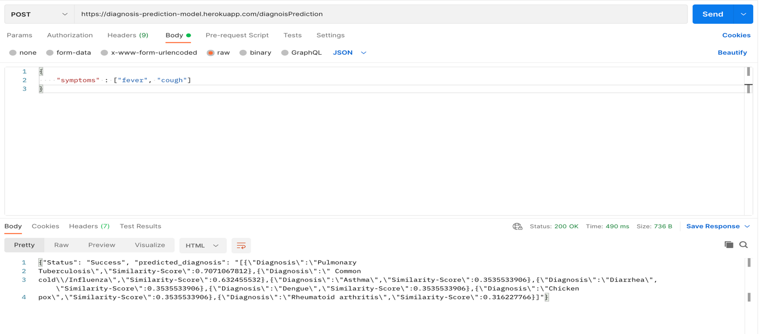

* **Recommendation Basis Diagnosis API: -**

URL - <https://diagnosis-prediction-model.herokuapp.com/recommendationBasisDiagnosis>

This API gives the patient / hospital staff recommendations on the possible treatment, investigation as well the department(speciality) the patient should be referred to.

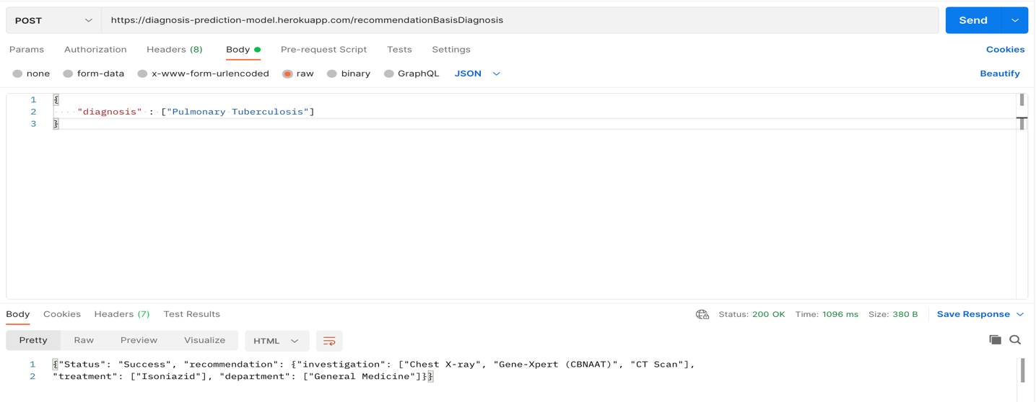

**How to set-up**

We have attached the readme file for both the backend and frontend defining the steps to deploy the application.

**We have added the sample dataset in GitHub Repo *(File Name - Symptom-Diseases-dataset.xlsx).* Since we had very less sample dataset, our recommendation is to use the symptoms that are given in sample set for a more accurate result.**

**Workflow with UI**

**Workflow with Video**